Бүгінгі Лабораториялық жұмыста істелінген Сумматор:
Двухразрядный сумматор
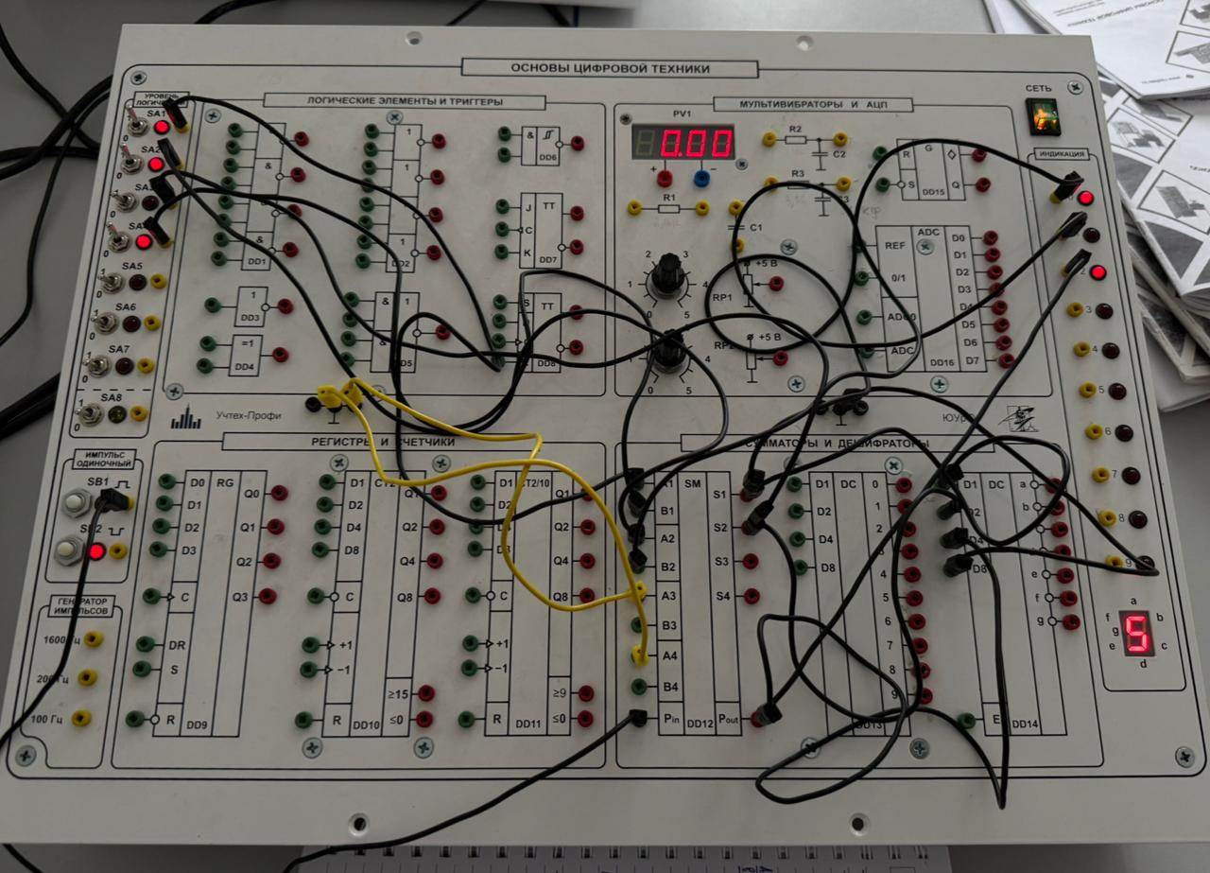

Схема:
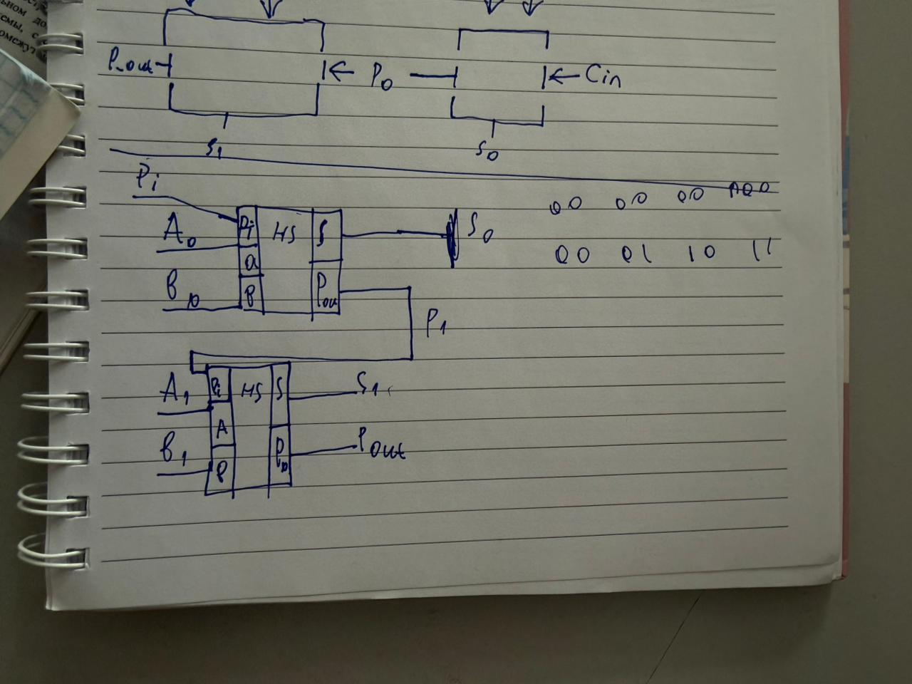

Ақиқат кестесі:

A_1 | A_0 | B_1 | B_0 | P_i | P_1 | S_0 | S_1 | P_out | A | B | Сумма
0 | 0 | 0 | 0 | 0 | 0 | 0 | 0 | 0 | 0 | 0 | 0
0 | 0 | 0 | 0 | 1 | 0 | 1 | 0 | 0 | 0 | 0 | 1
0 | 0 | 0 | 1 | 0 | 0 | 1 | 0 | 0 | 0 | 1 | 1
0 | 0 | 0 | 1 | 1 | 1 | 0 | 0 | 0 | 0 | 1 | 2
0 | 0 | 1 | 0 | 0 | 0 | 0 | 1 | 0 | 0 | 2 | 2
0 | 0 | 1 | 0 | 1 | 0 | 1 | 1 | 0 | 0 | 2 | 3
0 | 0 | 1 | 1 | 0 | 0 | 1 | 1 | 0 | 0 | 3 | 3
0 | 0 | 1 | 1 | 1 | 1 | 0 | 0 | 1 | 0 | 3 | 4
0 | 1 | 0 | 0 | 0 | 0 | 1 | 0 | 0 | 1 | 0 | 1
0 | 1 | 0 | 0 | 1 | 1 | 0 | 0 | 0 | 1 | 0 | 2
0 | 1 | 0 | 1 | 0 | 1 | 0 | 0 | 0 | 1 | 1 | 2
0 | 1 | 0 | 1 | 1 | 1 | 1 | 0 | 0 | 1 | 1 | 3
0 | 1 | 1 | 0 | 0 | 0 | 1 | 1 | 0 | 1 | 2 | 3
0 | 1 | 1 | 0 | 1 | 1 | 0 | 1 | 0 | 1 | 2 | 4
0 | 1 | 1 | 1 | 0 | 1 | 0 | 1 | 0 | 1 | 3 | 4
0 | 1 | 1 | 1 | 1 | 1 | 1 | 1 | 0 | 1 | 3 | 5
1 | 0 | 0 | 0 | 0 | 0 | 0 | 1 | 0 | 2 | 0 | 2
1 | 0 | 0 | 0 | 1 | 0 | 1 | 1 | 0 | 2 | 0 | 3
1 | 0 | 0 | 1 | 0 | 0 | 1 | 1 | 0 | 2 | 1 | 3
1 | 0 | 0 | 1 | 1 | 1 | 0 | 1 | 0 | 2 | 1 | 4
1 | 0 | 1 | 0 | 0 | 0 | 0 | 0 | 1 | 2 | 2 | 4
1 | 0 | 1 | 0 | 1 | 0 | 1 | 0 | 1 | 2 | 2 | 5
1 | 0 | 1 | 1 | 0 | 0 | 1 | 0 | 1 | 2 | 3 | 5
1 | 0 | 1 | 1 | 1 | 1 | 0 | 1 | 1 | 2 | 3 | 6
1 | 1 | 0 | 0 | 0 | 0 | 1 | 1 | 0 | 3 | 0 | 3
1 | 1 | 0 | 0 | 1 | 1 | 0 | 1 | 0 | 3 | 0 | 4
1 | 1 | 0 | 1 | 0 | 1 | 0 | 1 | 0 | 3 | 1 | 4
1 | 1 | 0 | 1 | 1 | 1 | 1 | 1 | 0 | 3 | 1 | 5
1 | 1 | 1 | 0 | 0 | 0 | 1 | 0 | 1 | 3 | 2 | 5
1 | 1 | 1 | 0 | 1 | 1 | 0 | 0 | 1 | 3 | 2 | 6
1 | 1 | 1 | 1 | 0 | 1 | 0 | 0 | 1 | 3 | 3 | 6
1 | 1 | 1 | 1 | 1 | 1 | 1 | 0 | 1 | 3 | 3 | 7

